# Florisoft Manual package adminstration



Welcome to the Florisoft manual for the Package administration. In Florisoft the intake and issue of kegs be administered.

## 1 Package administration

In order to begin with using the module, start up the Florisoft application and head to the “Package intake / issue” page.

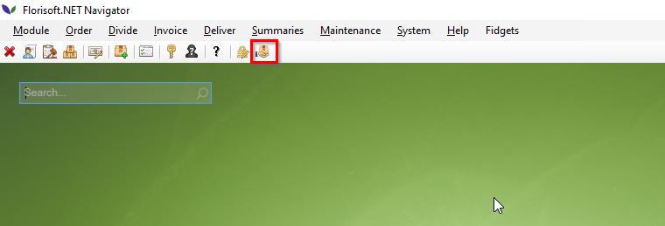

Once in the next screen, enter the relevant debtor number(nr.1), or select it from the list by pressing “…”.

Now select the package form(nr.2). Be aware: Intake is that the package LEAVES your administration.

At “remark” (nr.3) you could enter the receipt number of the package receipt booklet. This is not nessecary.

Once the information above (nr.1-3) has been filled out, you can start adding the packages to the list. Select the first open field beneath “Pieces” (nr.4) and fill in how many pieces you wish to send. The next open field is to determine what package(nr.5) it is, do this by entering the package code. The description will automactically be filled with the description of the package code filled in.

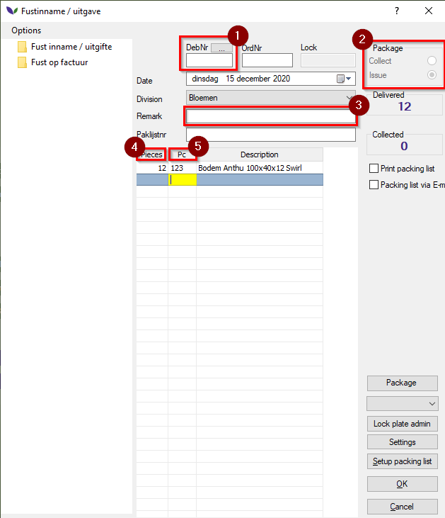

If you enter a code which is incorrect, a screen will pop up. This screen will allow you to find the package needed. Use the search option or scroll through the package numbers to find the desired package.

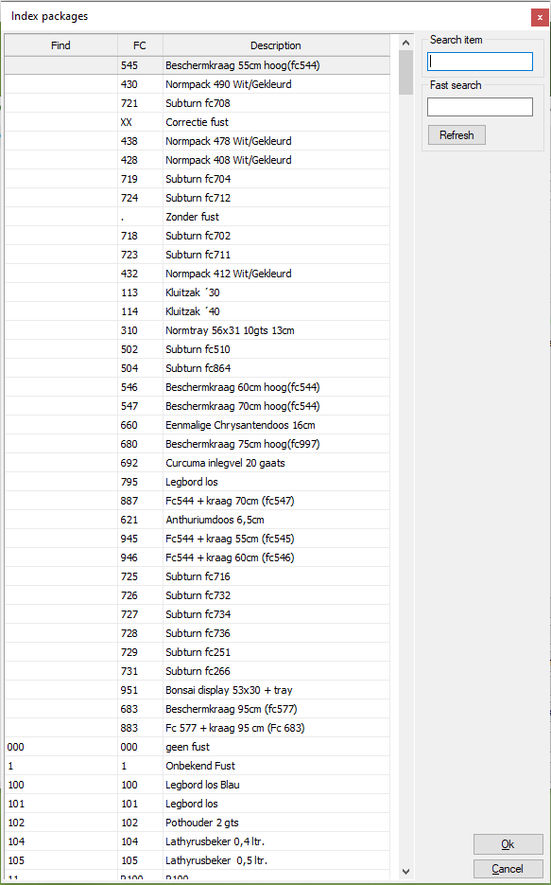

If you press the “Setup packing list” button, you can set how you wish for the packagelist to be printed. This can also be set to PDF.

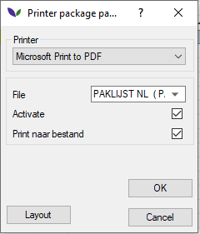

This only has to be done once. After the initial setup, you will only have to press OK to continue.

If you selected PDF, after you press OK it will ask you where you would like the PDF to be saved. Florisoft will remember this location and send following package lists to that location.

Now the packages have succesfully been administered. If you wish to see an overview of the current package administration, go to the Florisoft application and select “Package admin”. There you will find an overview of the packages.

